Emata, Bernadette Ice E. 202217783 BSIT-3C  
Reflection Paper

Working on my personal website has been one of the most memorable and fulfilling experiences I’ve had so far as an IT student. I handled everything myself—from planning the layout to writing the HTML and CSS code, troubleshooting errors, and refining the design. It wasn’t easy, but it helped me realize how far I’ve come with my skills and how much more I still want to learn. This project really pushed me to become more confident and creative as a developer.

I wanted my website to be something that truly reflects who I am. That’s why I chose to use the Poppins font for a modern, clean look, and added a linear gradient background to make the pages visually appealing. One of the first things I made was a sticky navigation bar, which I made sure stayed in place while scrolling. I also focused a lot on responsiveness—making sure the website looked good not just on a computer, but also on tablets and mobile devices. That took a lot of adjusting, especially when it came to spacing, font sizes, and layout flexibility.

The part that I’m most proud of is the card-style layout I used for different sections, like hobbies, education, projects, and quizzes. I carefully designed each card using CSS and reused the same styling across different pages so the design would be consistent. It wasn’t easy to match everything perfectly, especially when updating the hobbies page to follow the same style as the homepage. But I managed to do it, and the end result looked clean and cohesive.

Throughout this project, I learned a lot—not just about web development, but also about patience and problem-solving. I now understand how important responsive design is and how to use media queries to adjust layouts based on screen size. I learned how to structure HTML and CSS more efficiently, and how to make my code more reusable by organizing my styles properly. I also got a better understanding of user experience (UX), especially when it comes to layout consistency, readability, and navigation.

Another valuable lesson I learned was the importance of attention to detail. Even small things like button alignment, font weight, or padding can make a big difference in how professional a website looks. I found myself going back many times just to fix minor things or improve the user interface. It taught me not to rush and to take pride in polishing my work.

This website isn’t just a school project to me—it’s a portfolio that shows what I’m capable of right now. It gave me a sense of ownership, and I enjoyed seeing my progress every step of the way. I’m proud of what I’ve accomplished, and this experience inspired me to keep improving, keep building, and hopefully one day create even more advanced websites or applications.

Photos of my Website

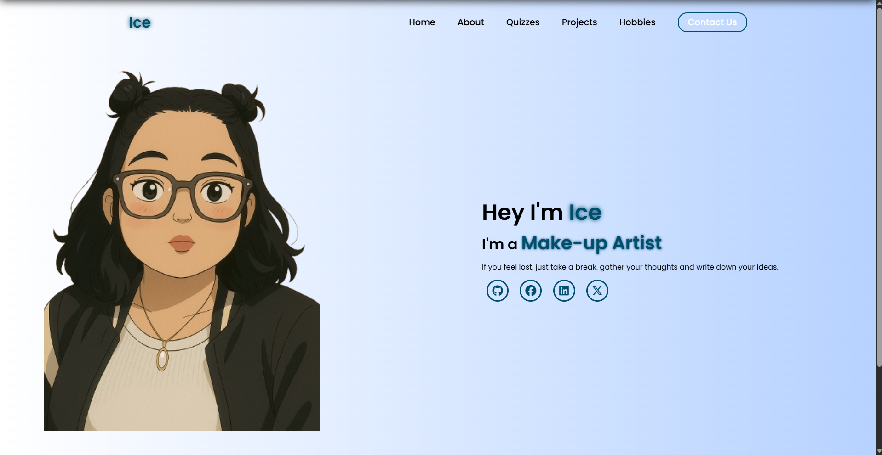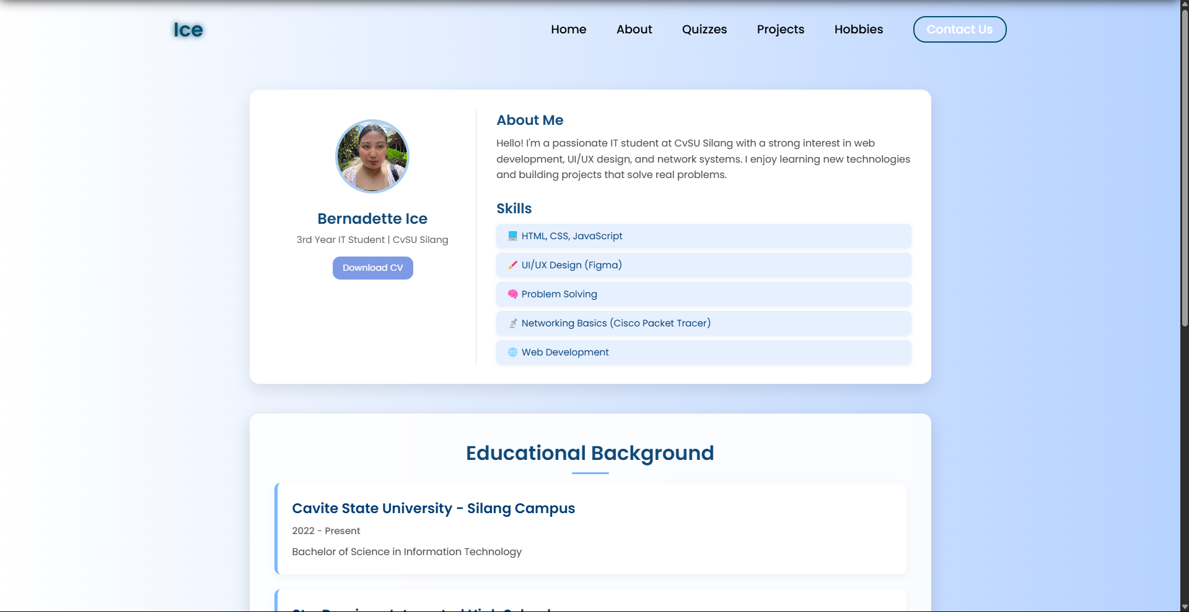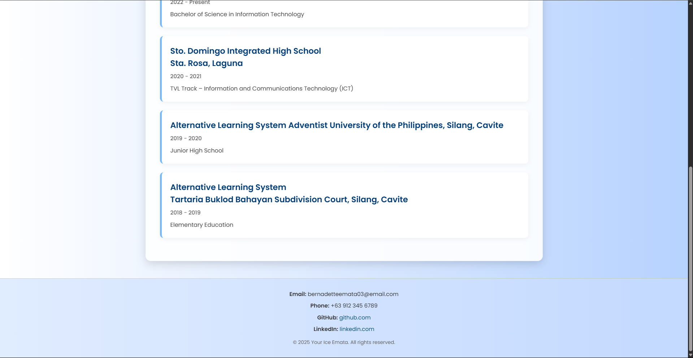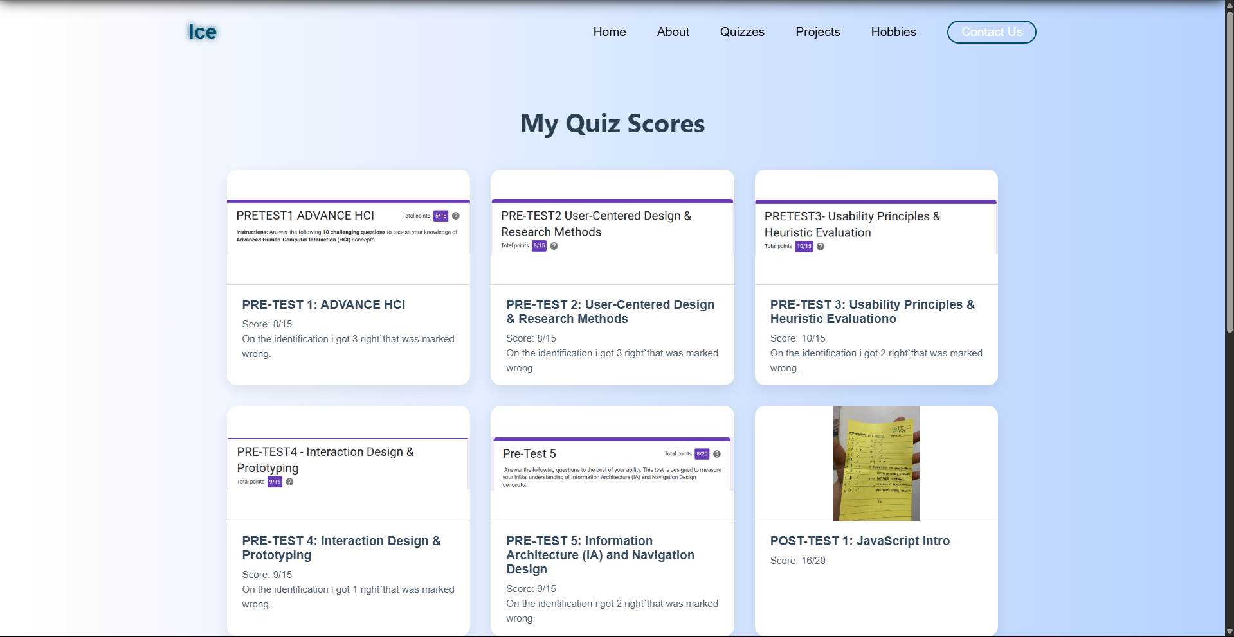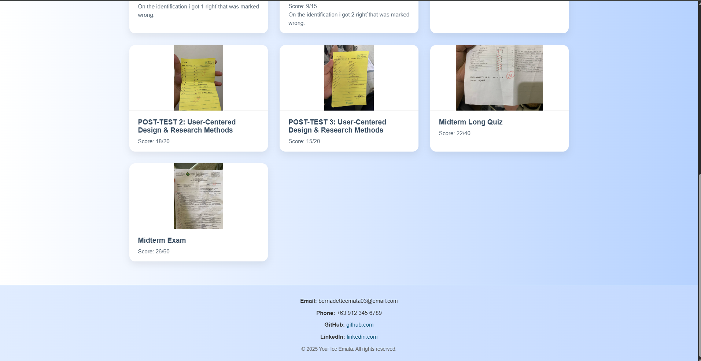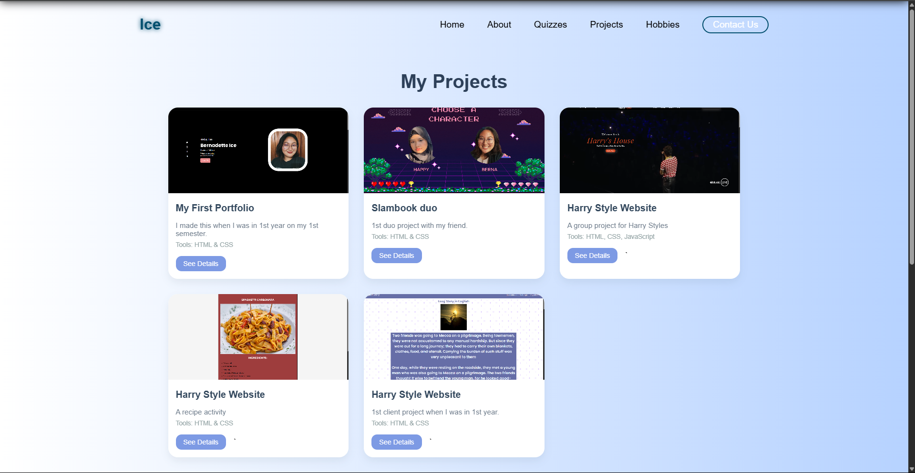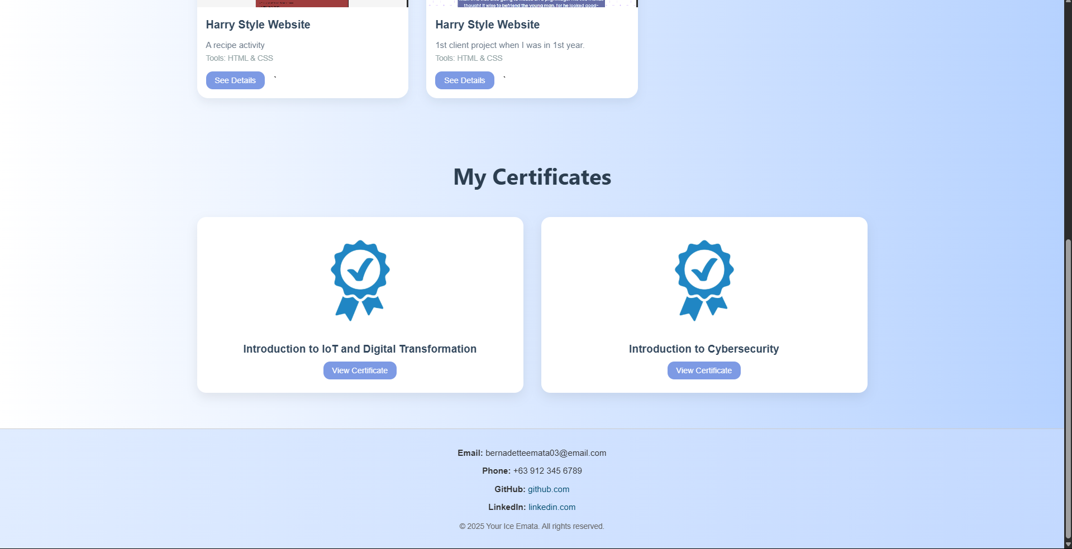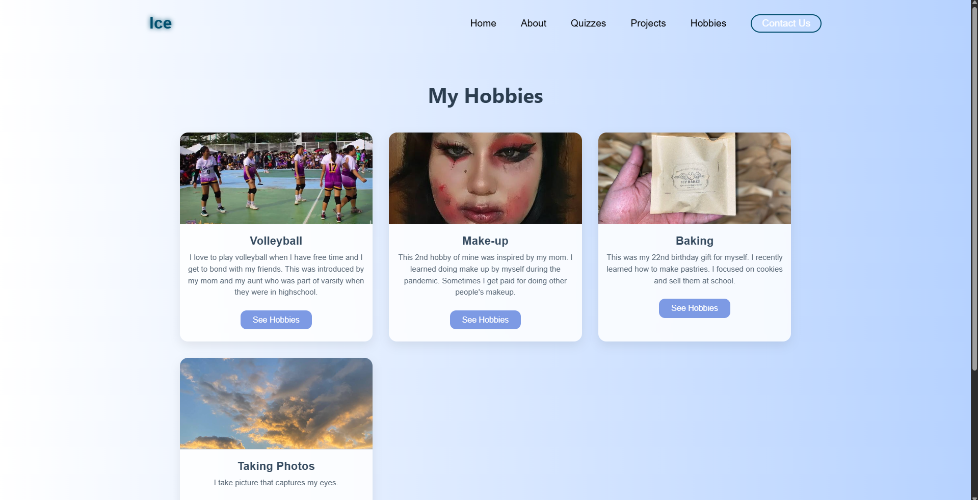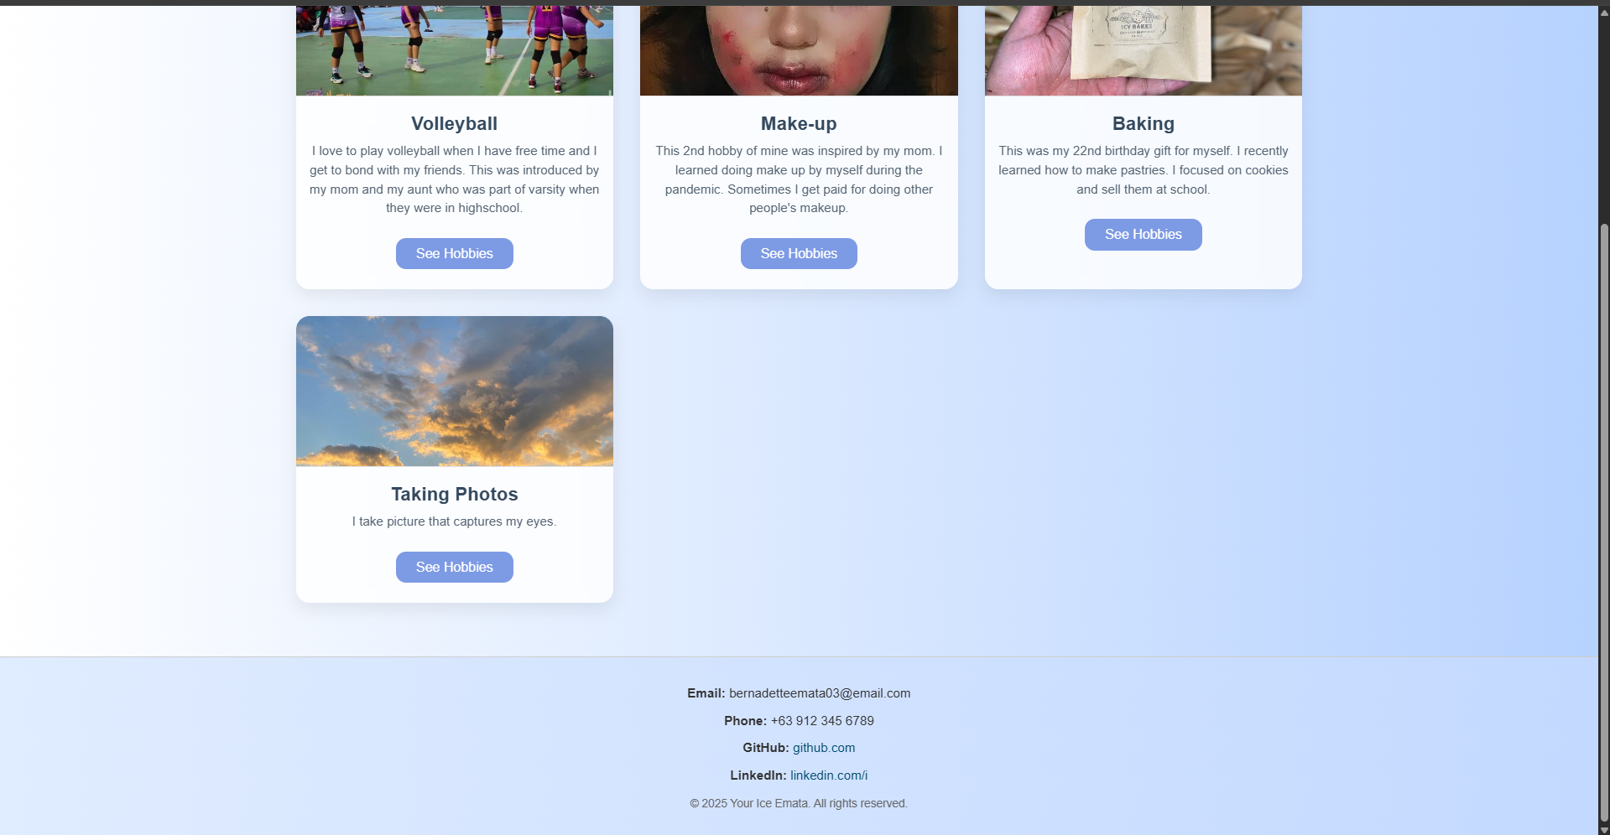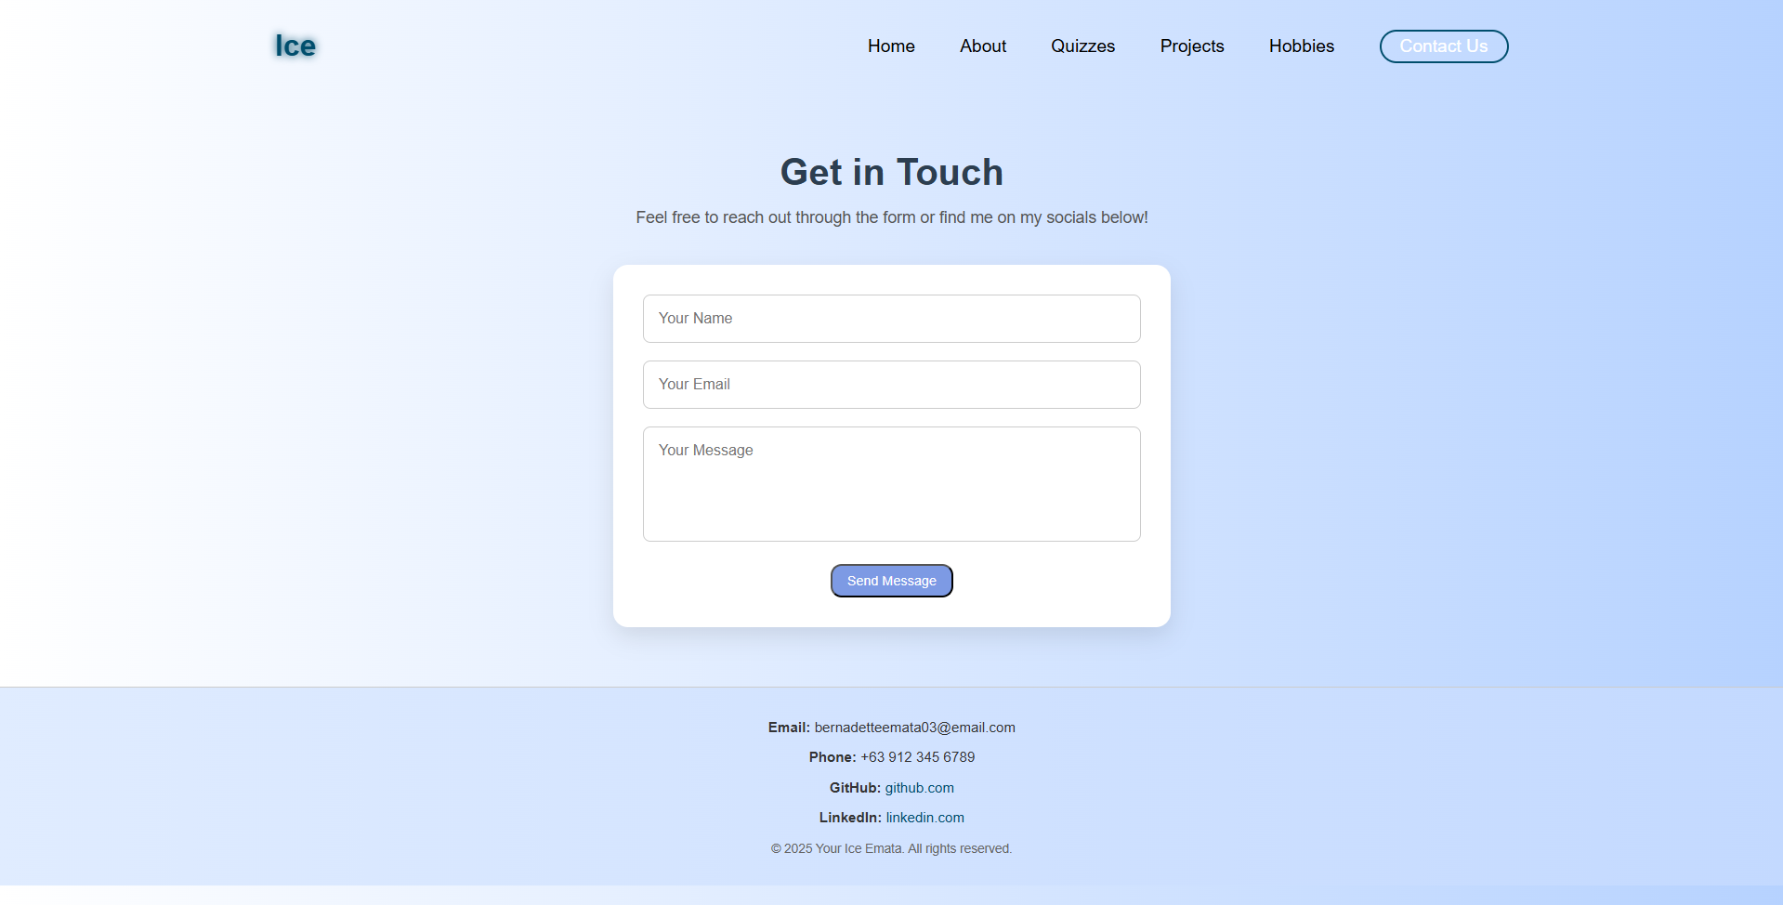

Simple flowchart of my website

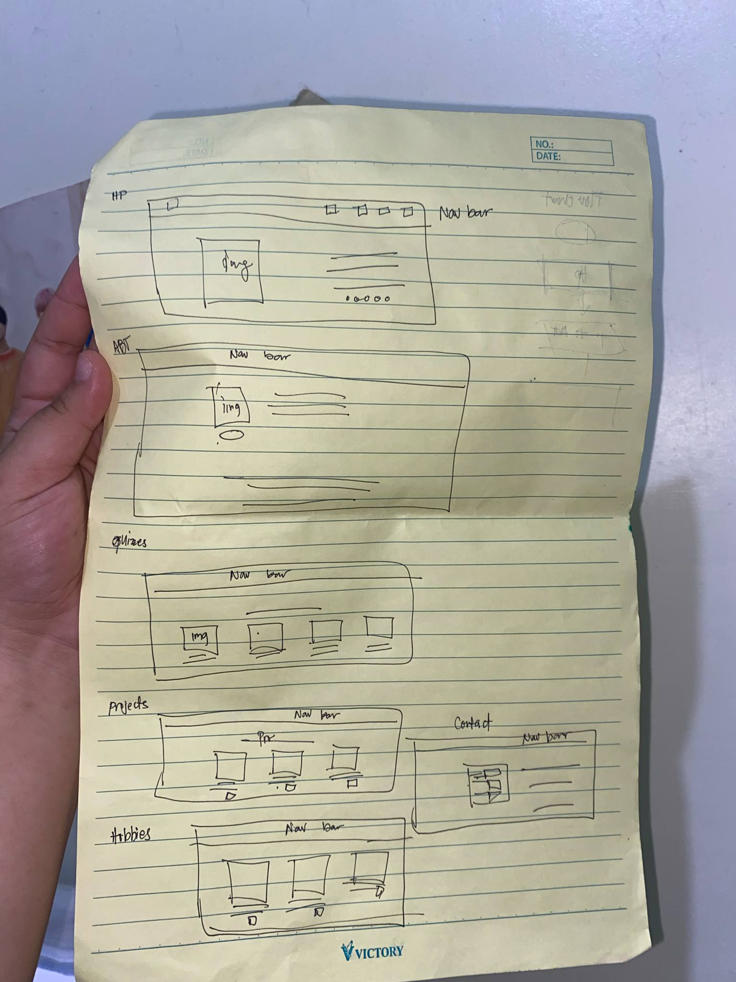  
sketch structure of my website

